High Availablity & Failover IP & Database Synchronization & Freeswitch Calls
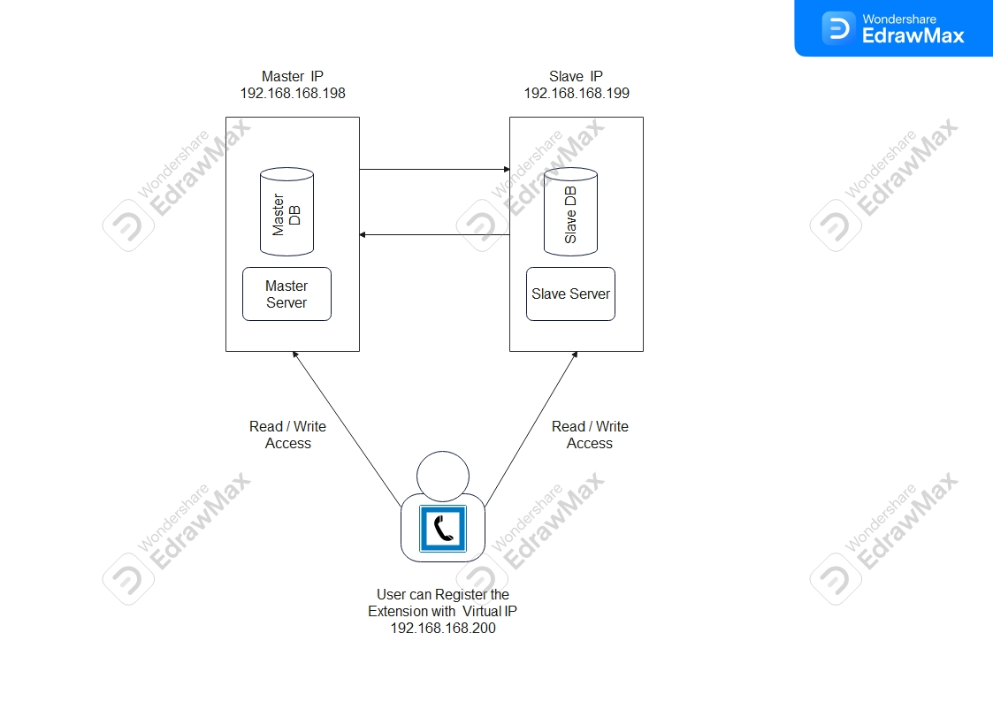
Step 1: VRRP using keepalived

Network Scenario:
1. Server1: 192.168.168.43 (eth0)
2. Server2: 192.168.168.136 (eth0)
3. Virtual IP: 192.168.168.200

Setup Keepalived on Server1.
vim /etc/keepalived/keepalived.conf
! Configuration File for keepalived
vrrp_instance VI_1 {
state MASTER
interface ens32
virtual_router_id 101
priority 101
advert_int 1
authentication {
auth_type PASS
auth_pass 1111
}
virtual_ipaddress {
192.168.168.200
}

Setup Keepalived on Server2.
vim /etc/keepalived/keepalived.conf
vrrp_instance VI_1 {
state MASTER
interface ens192
virtual_router_id 101
priority 100
advert_int 1
authentication {
auth_type PASS
auth_pass 1111
}
virtual_ipaddress {
192.168.168.168
}
}

Enable the keepalived service and start on both the servers
sudo systemctl enable keepalived
sudo service keepalived start

Step 2: High availability implementation in freeswitch
Track Calls
In the SIP profiles you must have track-calls enabled.

So if your call has 2 legs, you must enable track-calls on both profiles that the call uses.

This is done simply by using this config in your both SIP profiles.

<param name="track-calls" value="true"/>

Failover to a Second Server
If you want to recover calls a second server, then you must have some way of sharing the call recovery data.
ODBC or PostgreSQL are possible methods, and to do so, you must specify a DSN for all involved sip profiles (like you needed track-calls on all involved profiles).
usr/local/freeswitch/conf/sip_profiles/internal.xml
Add the following information on both servers
<param name="odbc-dsn" value="pgsql://hostaddr=127.0.0.1 dbname=freeswitch user=freeswitch password='' options='-c client_min_messages=NOTICE' application_name='freeswitch'"/>
<param name="odbc-dsn" value="pgsql://hostaddr=192.168.168.43 dbname=cxc_phase2 user=cxcuser password='P@ssw0rd'"/>
usr/local/freeswitch/conf/autoload_config/switch.conf
Add the following information in switch.conf location
<param name="core-recovery-db-dsn" value="pgsql://hostaddr=192.168.168.43 dbname=cxc_phase2 user=cxcuser password='P@ssw0rd'"/>
Note: (If Necessary )
If you want to clone everything, you will also need to add DSN information to
voicemail.conf.xml
The hostname on both machines needs to be the same, as the sql query to recover calls selects by hostname. To do this, simply set the following parameter in switch.conf.xml on both FS instances to the same value:
usr/local/freeswitch/conf/autoload_config/switch.conf
<param name="switchname" value="freeswitch01"/>
Add the following information in vars.conf file
/usr/local/freeswitch/conf/vars.xml
<X-PRE-PROCESS cmd="set" data="api_on_startup=fsctl recover"/>

Step 3: Installation about arping module
Install arping
apt-get install arping
Allow FreeSWITCH to bind to nonlocal IP
Add the following line to /etc/sysctl.conf
echo 'net.ipv4.ip_nonlocal_bind=1' >> /etc/sysctl.conf

Restart networking:
/etc/init.d/networking restart
sysctl -p
You should see:
net.ipv4.ip_nonlocal_bind = 1
If you don't, get the above result after the command do the following
sysctl -w net.ipv4.ip_forward=1

Add an ethernet alias for the floating IP
Add the following to /etc/network/interfaces on both primary and secondary FreeSWITCH servers:
auto ens32
iface ens32 inet static
address 192.168.168.43
netmask 255.255.255.255
gateway 192.168.168.168

Then restart network service using the following command
/etc/init.d/networking restart

Start primary FreeSWITCH server
Bring up the floating IP
Make sure that the SIP profiles are set to listen on your floating IP
usr/local/freeswitch/conf/sip_profiles/internal.xml
usr/local/freeswitch/conf/sip_profiles/external.xml

<param name="rtp-ip" value="192.168.168.200"/>
<param name="sip-ip" value="192.168.168.200"/>
<param name="presence-hosts" value="192.168.168.200"/>
<param name="ext-rtp-ip" value="192.168.168.200"/>
<param name="ext-sip-ip" value="192.168.168.200"/>
Then restart freeswitch service the following command
systemctl restart freeswitch

Start secondary FreeSWITCH server

Bring up the floating IP
Make sure that the SIP profiles are set to listen on your floating IP
usr/local/freeswitch/conf/sip_profiles/internal.xml
usr/local/freeswitch/conf/sip_profiles/external.xml

<param name="rtp-ip" value="192.168.168.200"/>
<param name="sip-ip" value="192.168.168.200"/>
<param name="presence-hosts" value="192.168.168.200"/>
<param name="ext-rtp-ip" value="192.168.168.200"/>
<param name="ext-sip-ip" value="192.168.168.200"/>
Then restart freeswitch service the following command
systemctl restart freeswitch

TEST!
Make a call and don't hang up.

Crash the primary server
fs_cli -x 'fsctl crash'
Bring down the floating IP

ifdown eth0:0
Recover the calls on the secondary server
Bring up the floating IP

ifup eth0:0
Run arping command to update the router

arping -q -c 3 -A -I eth0:0 10.10.10.11
Recover the calls.

fs_cli -x 'sofia recover'

Voilà, the call should continue with only 3-5 seconds of audio dropped!!
Step 4: Database synchronization
Master slave replication on postgresql
apt-get install -y postgresql-9.6 postgresql-contrib-9.6 ( Please leave it if already installed )
systemctl enable postgresql
netstat -plntu
From the root account, log in to the postgres user with the su command, then access the postgres front-end terminal psql.
su - postgres
psql
Please change the password for the postgres user and check the connection info with postgres queries below.
\password postgres
\conninfo

Step 5: Firewall configuration
We can install ufw from the main Ubuntu repository with the apt command.

apt-get install -y ufw
Add new services to the UFW firewall: add SSH and PostgreSQL services with commands below.

ufw allow ssh
ufw allow postgresql
Enable the UFW firewall and check the status.

ufw enable
ufw status

Step 6: Configure the postgres master server
The master server has the IP address 192.168.168.43, and the postgres service will run under that IP with default port. The master server will have permission for the READ and WRITE to the database, and perform streaming replication to the slave server.

Go to the postgres configuration directory '/etc/postgresql/11/main' and edit the postgresql.conf file with vim.

cd /etc/postgresql/9.6/main/
vim postgresql.conf
Uncomment 'listen_addresses' line and change the value to the master server IP address '192.168.168.43'.

listen_addresses = '192.168.168.43'
Uncomment 'wal_level' line and change value to the 'hot_standby'.

wal_level = hot_standby
For the synchronization level, we will use local sync. Uncomment and change value line as below.

synchronous_commit = local
Enable archiving mode and change the archive_command option to the command 'cp %p /var/lib/postgresql/11/main/archive/%f'.

archive_mode = on
archive_command = 'cp %p /var/lib/postgresql/11/main/archive/%f'
For the 'Replication' settings, in this tutorial we use 2 servers only, master and slave, uncomment the 'wal_sender' line and change value to 2, and for the 'wal_keep_segments' value is 10.

max_wal_senders = 2
wal_keep_segments = 10
For the application name, uncomment 'synchronous_standby_names' line and change the value to the name 'pgslave001'.

synchronous_standby_names = 'pgslave001'
Save the file and exit the editor.

In the postgresql.conf file, the archive mode is enabled, so we need to create a new directory for the archive. Create a new archive directory, change the permission and change the owner to the postgres user.

mkdir -p /var/lib/postgresql/11/main/archive/
chmod 700 /var/lib/postgresql/11/main/archive/
chown -R postgres:postgres /var/lib/postgresql/11/main/archive/
Next, edit pg_hba.conf file for authentication configuration.

vim pg_hba.conf
Paste configuration below to the end of the line.

# Localhost
host replication replica 127.0.0.1/32 md5

# PostgreSQL Master IP address
host replication replica 192.168.168.43/32 md5

# PostgreSQL SLave IP address
host replication replica 192.168.168.136/32 md5
Save and exit, then restart PostgreSQL.

systemctl restart postgresql
PostgreSQL is running under the IP address 192.168.168.43, check it with netstat command.

netstat -plntu
Next, create a new user for replication. We will create a new user named 'replica' with password 'aqwe123@'. Please choose a secure password here for your setup! Log in to the postgres user and access the postgres front-end terminal psql.

su - postgres
psql
Create new 'replica' user with password 'aqwe123@' with postgres query below.

CREATE USER replica REPLICATION LOGIN ENCRYPTED PASSWORD 'aqwe123@';
Now check the new user with 'du' query below, and you will see the replica user with replication privileges.

\du
MASTER server configuration has been completed.

Step 7: Configure the postgres slave server
The SLAVE server has IP address 192.168.168.136. And this server will only have a READ permission to the database. The Postgres database server will run under the IP address of the server, not a localhost IP.

Stop the postgres service on the slave server with the systemctl command below.

systemctl stop postgresql
Go to the Postgres configuration directory '/etc/postgresql/11/main', then edit the configuration file 'postgresql.conf'.

cd /etc/postgresql11/main/
vim postgresql.conf
Uncomment the listen_addresses line and replace the value with the slave server IP address 192.168.168.136.

listen_addresses = '192.168.168.136'
Uncomment 'wal_level' line and change the value to the 'hot_standby'.

wal_level = hot_standby
For the synchronization level, uncomment the synchronous_commit line and change the value as shown below.

synchronous_commit = local
For the replication setting, uncomment the max_wal_senders line and replace the value with '2' because just use 2 servers. And for the wal_keep_segments, change the value to '10'.

max_wal_senders = 2
wal_keep_segments = 10
Uncomment the 'synchronous_standby_names' line for the application name and change value to the name 'pgslave001'.

synchronous_standby_names = 'pgslave001'
Enable hot_standby for the slave server by uncommenting the following line and change value to 'on'.

hot_standby = on
Save the file and exit the editor.

Step 8: Copy postgres data master to slave
Next, we want to replace the postgres main directory on the 'SLAVE' server with the main data directory from 'MASTER' server.

Log in to the SLAVE server and access postgres user.

su - postgres
Go to the postgres data directory 'main' and backup it by renaming the directory name.

cd 11/
mv main main-backup
Create new 'main' directory as 'postgres' user and make sure have a permission like the main-bekup directory.

mkdir main/
chmod 700 main/
Next, copy the main directory from the MASTER server to the SLAVE server with pg_basebackup command, we will use replica user to perform this data copy.
pg_basebackup -h 192.168.168.43 -U replica -p 5432 -D /var/lib/postgresql/11/main/ -Fp -Xs -P -R
When the data transfer is complete, go to the main data directory and create a new recovery.conf file.

cd /var/lib/postgresql/11/main/
vim recovery.conf
Paste the configuration below:

standby_mode = 'on'
primary_conninfo = 'host=192.168.168.43 port=5432 user=replica password=aqwe123@ application_name=pgslave001'
restore_command = 'cp /var/lib/postgresql/11/main/archive/%f %p'
trigger_file = '/tmp/postgresql.trigger.5432'
Save and exit, then change the permissions of the file to 600 with chmod.

chmod 600 recovery.conf

Now start PostgreSQL 11 on the SLAVE server and make sure the postgres service is running on IP address 192.168.168.136 with netstat.

systemctl start postgresql
netstat -plntu

